# Assignment 1: Diary Application Review

## Introduce yourself (10 points)

Introduce yourself in the Discussion Forum and, optionally, list some useful resources.

Hi all,

My name is Wayne Moir and I have been working as a front end designer for an e-learning company based in Derby, UK for the past four years; during which time I have developed a passion for usable and accessible interfaces.

During my time with the company we have seen a huge increase in customer demand for mobile support in our software. As a result we have shifted the design of our microsites to make use of responsive design principles; and hope that completing this course will prepare me in the best way possible to make our application based offerings suitable for mobile use.

Resource wise I primarily use Smashing Magazine and find the Smashing Network extremely valuable, if a little difficult to keep up to date with. Although they are not mobile focused, currently I am reading Web Form Design by Luke Wroblewski, Principles of Beautiful Web Design by Jason Beaird, and Seductive Interaction Design by Stephen Anderson

I am always eager to make new contacts in the industry and connect with other designers or developers so if you wish to connect with me on [LinkedIn](http://www.linkedin.com/in/waynemoir) or [contact me](http://www.waynemoir.com/contact/) you are welcome to do so.

## Mobile user experience (30 points)

By testing the page out on a mobile device, identify the good, the bad of the application from the user's perspective.

* Navigating to site is a chore on any mobile device due to the length of the URL.
* Initial display of the site is a state in which the desktop version has simply been zoomed out to fit the screen size. This means that in order to be able to read the content you have to zoom in resulting in there to be a lot of scrolling in required to use the application.

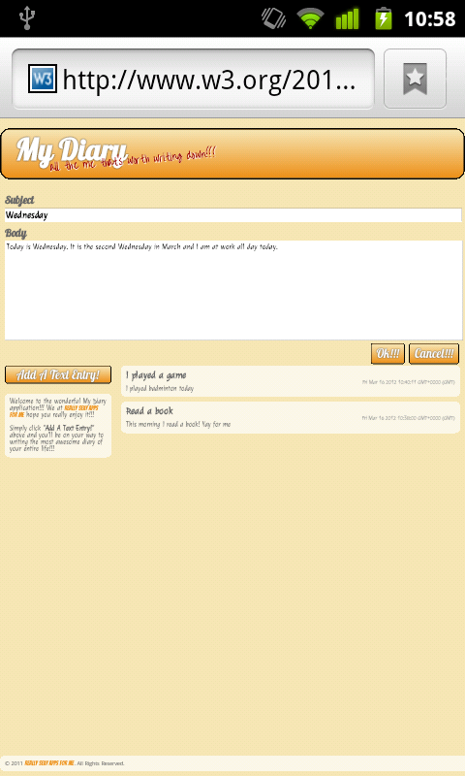

* The footer is positioned at the very bottom of the screen a long way from any of the page content. This means that the content inside it is very unlikely to be read and that the page has a lot of very unnecessary vertical spacing.
* The footer overlaps the page content when viewed in landscape mode on a Samsung Galaxy S.

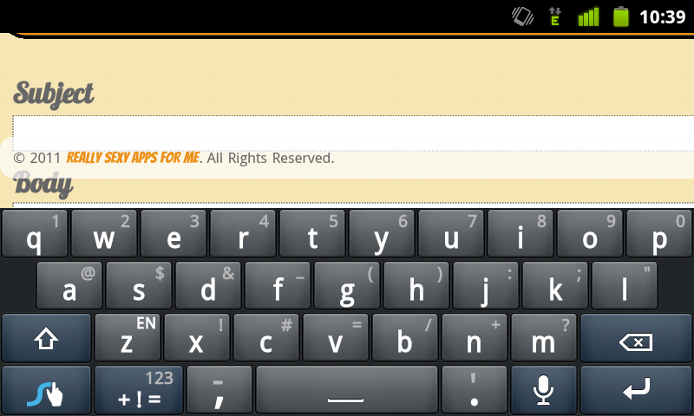



* The link to robineko.com is very difficult to spot and has a small hit area making it awkward to use on a mobile device.
* The text entry boxes are extremely wide making it very difficult to read back what you have typed. Reading back any long entries in this box require a lot of zooming in and out.



* The ok and cancel buttons are right aligned, this goes against best practice for making the form easy to complete, and makes it difficult for the user to locate on a mobile due to the horizontal scrolling involved.
* The site exhibits an inconsistent experience when viewed on mobile devices with the “Welcome to the diary” text is resized to fit the screen zoom state and aid reading when viewed on the Huawei u8110, but not when viewed on a Samsung Galaxy S. I am not sure if this is perhaps a device specific feature of the u8110.
* Whilst not a mobile browser, in Internet Explorer 8 there is no background colour on either the welcome text or the header making the text very difficult to read and appear unprofessional. This suggests that if the site does not work a browser as modern as this it may have issues on older mobile devices.

Mobile delivery (30 points)

Analyse how the site would perform on a mobile network. Can you identify performance issues and what is causing those issues? What could be done to improve the applications performance? (hint: look at the Network performance indicator in Firebug, or Chrome/Safari's developer tools).

The site was quick on load on a Samsung Galaxy S using the Edge network. Looking at the Net Panel in Firebug revealed a strange loading order to the CSS, with the rest.css being the last loaded CSS file to load when I logically would have expected it to be the first to avoid reflow of the page.

The page size is reported at 131.3KB which initially appears to be reasonably good however looking into this a little deeper reveals that the majority of this size is made up of custom fonts, reducing the number of custom fonts used could greatly reduce the file size.

The page load time on a desktop browser is reported by Firebug to be 878ms over 10mb fibre, page load on a Samsung Galaxy S using the Edge network was not much longer. Again this initially appears to be reasonably good however looking into this a little deeper reveals that the majority of this time was spent on processing the CSS. This may explain why the speed difference between the desktop and the mobile was not that great in my case. The Samsung Galaxy S is quite a powerful phone, testing the load time on an older device may produce very different results.

## Markup - content, structure, style - (30 points)

By looking at the (HTML, CSS, and JavaScript) code of the site, what could be improved and why? (Don’t just validate, go in there and have a good look!)

The reset CSS is loaded using @import from diary.css, to my knowledge this is not considered best practice in the production of high performance sites (<http://www.stevesouders.com/blog/2009/04/09/dont-use-import/>).

The coding used in the CSS file is inconsistent (spacing between property’s and values) and appears to have no logic to the structure (h1, h2 at the top and h3 at the bottom etc.). Whilst this may not impact mobile performance, it will certainly impact readability with regard future changes to the code.

The HTML contains some HTML5 elements (e.g. header, footer and nav) but not others where you might expect them, the input for new diary entries should be marked up as a form and the sentences used on the page should be marked up as paragraphs not divs.

At first glance the structure of the JavaScript appears reasonable however the site is written in such a way that it does not function without JavaScript turned on, this could be a problem when using older mobile devices. If JavaScript is required in order for the site to function then the user should be notified of this, in the case of the site currently the message ‘XXX’ is displayed when JavaScript is turned off which does not help the end user.

## Additional

A large part of writing great applications is understanding what causes pain and joy to users. So at the same time, try to use at least one of the applications that you use commonly as a Web application accessed through your mobile device for the duration of the week. Do you see pain points that relate to those in the example diary application?

Using the web through a mobile browser for any length of time quickly becomes a pain, sites such as Smashing Magazine and Net Magazine offer mobile optimisations and versions which are on the whole a joy to use to a modern smartphone. However the majority of the web exhibits the same issues as the diary application and quickly becomes very frustrating with the amount of zooming and scrolling involved in order to be able to read the content. I dread to think what it would be like using an older mobile phone to access the web over a slow connection.